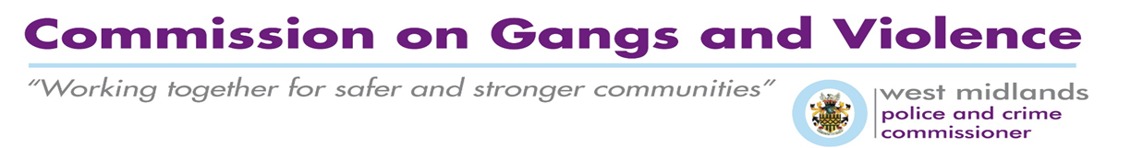
Use this form to provide information on your organisation and project which is needed by the Office of the Police and Crime Commissioner to ensure your proposal meets the criteria for funding. The information you provide will be used to help us decide the projects that will be funded.
Before completing the application please read the accompanying criteria and guidance notes. The deadline for the receipt of applications is Monday 17 December at 5pm.
Once we receive your completed application it will go through the Panel process as set out in the criteria and guidance notes.
The Application Form is a Word Document which allows applicants to add lines to expand their answers further within specified word count.
Please do not provide additional attachments other than those requested as these will not be considered.
Please send completed form to: pcc_commissioning@west-midlands.pnn.police.uk

All queries must be directed to: russell.fletcher@west-midlands.pnn.police.uk

Commission on Gangs and Violence
Background Information Form

- About you and your organisation/group

Project name:

Name of organisation/group: | Organisation/group address:

Project contact/owner: | Position in organisation: | Contact details:

- Does your organisation/group hold a separate bank account which has at least two signatories?

Yes No (delete as appropriate)

- Please provide details of your website (If you have one) or other public social media pages and platforms used e.g. Facebook groups, Twitter feeds etc.

- Please list the names, addresses and position held of all members of your organisation’s management committee or board of directors. Continue on a separate sheet if necessary.

Name | Address | Position

- a) Please tell us about all previous West Midlands Police / Office of the West Midlands Police and Crime Commissioner funding you have previously received or currently applied for:

Project | Funding programme | Amount awarded | Financial year awarded

b) Please provide any details of project and services delivered over the past 3 years that are relevant to the application e.g. HMPPS, Local Authority, Big Lottery, Charitable Trusts etc.
Project | Funding programme | Amount awarded | Financial year awarded

- About the project

Which area of Birmingham will this project take place in?

Why is the project / activities needed? [Word Limit: 250 Words]

What is the project / activities that will be delivered to meet the need described?
[Word Limit: 500 Words]

How will you engage project beneficiaries and sustain their involvement?
[Word Limit: 250 Words]

- Outputs and outcomes

Outputs to be delivered:
Use this section to describe what outputs will be delivered and who will benefit. Explain how you will measure the success of the project as it is being delivered.

Example 1: running 10 sessions of a homework club between September and December.
Example 2: 30 people participating in after school club and attending 75% of the sessions run.

Outcome evidence:
Outcomes are the changes and achievements resulting from your project/activity.
Provide information about what do you want to achieve by delivering this project/activity and what difference you expect it to make within the local community.

Example 1: 30 people attaining x’ standard or attaining ‘y’ qualification.
Example 2: 10 per cent reduction in anti-social behaviour in the area as evidenced by monitoring of graffiti levels over the six month period January – June.

- Evaluation and Evidence
Use this space to explain how you will evaluate the project and how you will ensure that there will be outcomes for young people who take part in your project. (Word Limit 250 words)

Timescales
Project start date: |  | Project end date:

Timescale  (day/week/month) | Key milestones and activities to be undertaken

- Project costs and funding

Please confirm whether the costs for the project are to be entirely funded by the grant or whether additional funding is required. If additional funding is required please state whether the funding has been secured and if so from whom. If not where will the additional funding come from and the timescales involved.
Itemised breakdown  of costs* | (A) Amount from PCC | (B) Amount contributed from other funding  If applicable | (A+B) Total cost
TOTAL:

- Please use this space to describe any other resources that you have committed to the project. This might include use of your website, volunteers, or other resources.

When you have completed the form, please read and sign below.

I certify that the information supplied is accurate to the best of my knowledge. I understand and accept that providing deliberate false information could result in legal action being taken against me and withdrawal or recovery of funds awarded.
(WET SIGNATURE NOT REQUIRED)

Signed for and on behalf of:

Name:

Position:

Date:

